SUPPLEMENTAL MATERIAL

Figure S1. Photograph of vegetation conditions at a marshbird survey location on the Pembina Wildlife Management Area in northwestern Minnesota, USA. This photograph was taken on 24 May 2015 in the spring prior to aerial herbicide application by the Minnesota Department of Natural Resources during late summer-early autumn 2015 to control invasive cattail (*Typha* spp.). Both treatment and control survey locations at all study sites had vegetation similar to that in this photograph. The green vegetation in the foreground is on the edge of a water control structure.

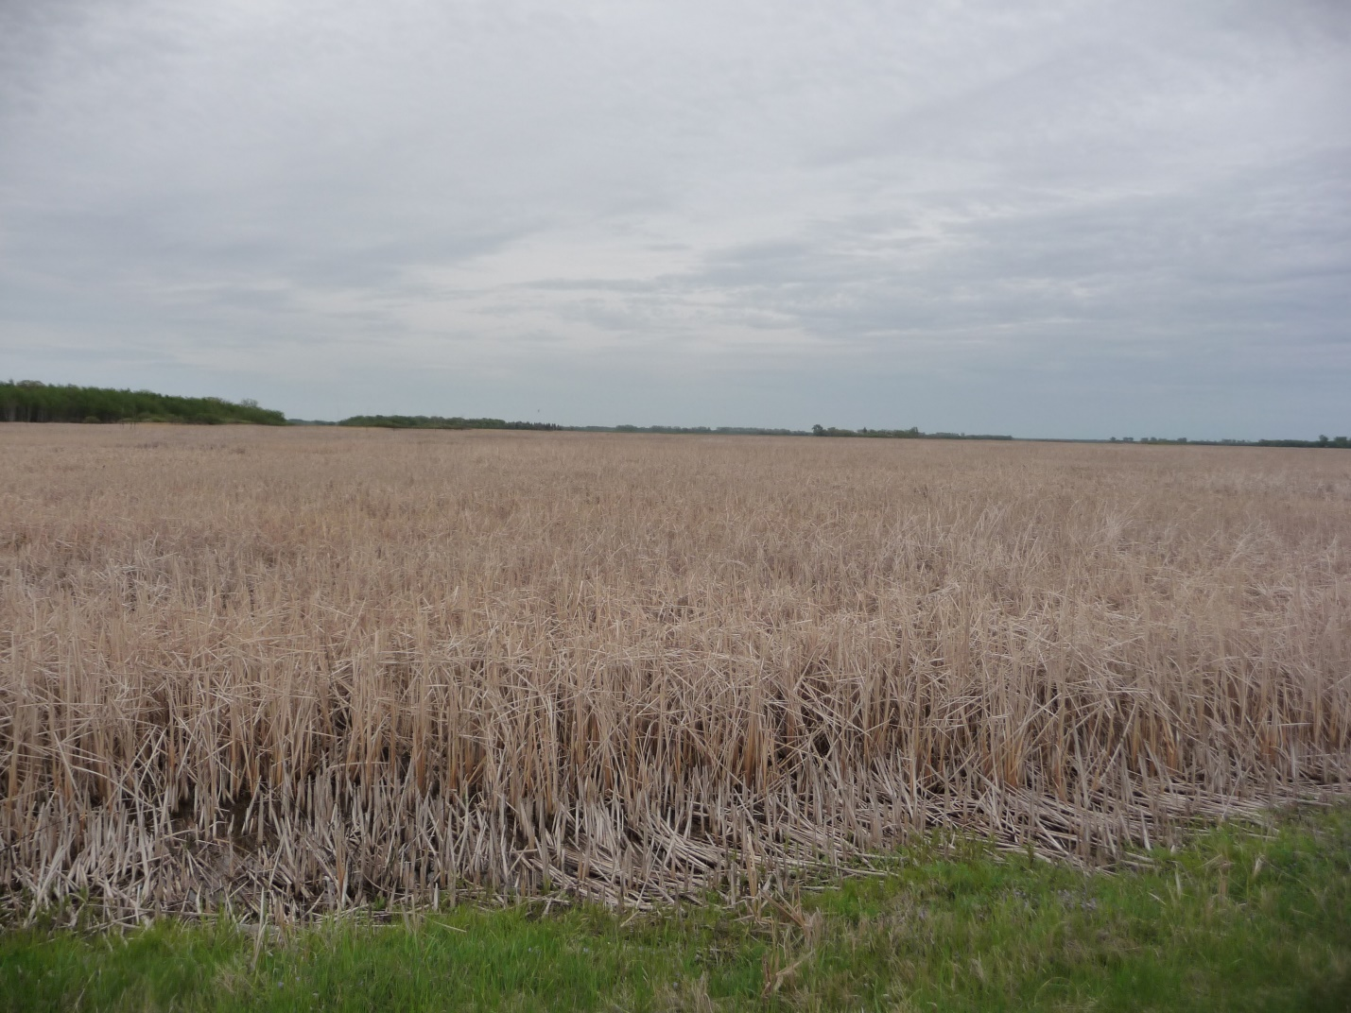

Figure S2. Aerial image from spring 2016 of the Beaches Lake Wildlife Management Area in northwestern Minnesota, USA. The rectangular areas of brown vegetation resulted from aerial herbicide application in late summer–early autumn 2015 by the Minnesota Department of Natural Resources to control cattail (*Typha* spp.).

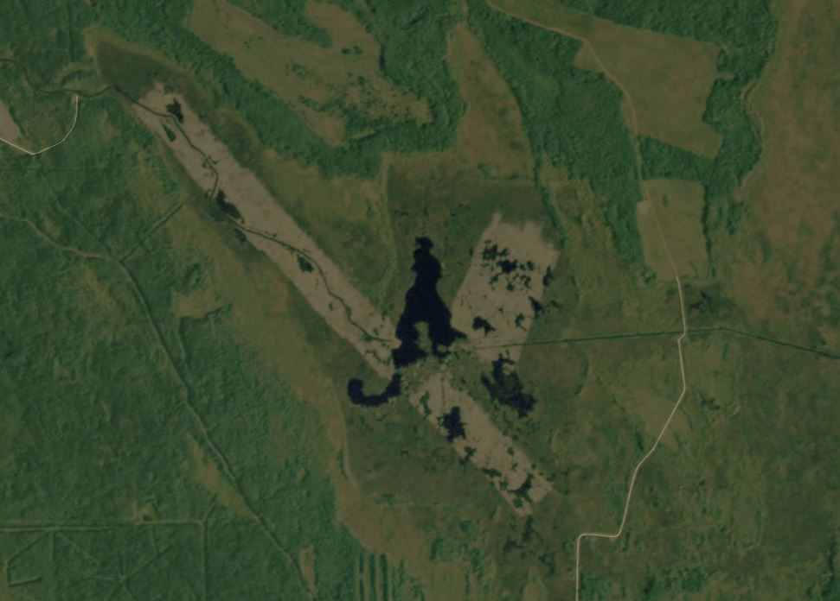

Figure S3. Aerial images of Elm Lake Wildlife Management Area (WMA) in northwestern Minnesota, USA from 2013 (2 years prior to herbicide application to control cattail [*Typha* spp.]) and 2019 (4 years following herbicide application in late summer–early autumn 2015). The area treated with herbicide is on the western end of the WMA and in the 2019 photo, includes considerably more open water than the area on the eastern portion of the WMA, which was not treated with herbicide.

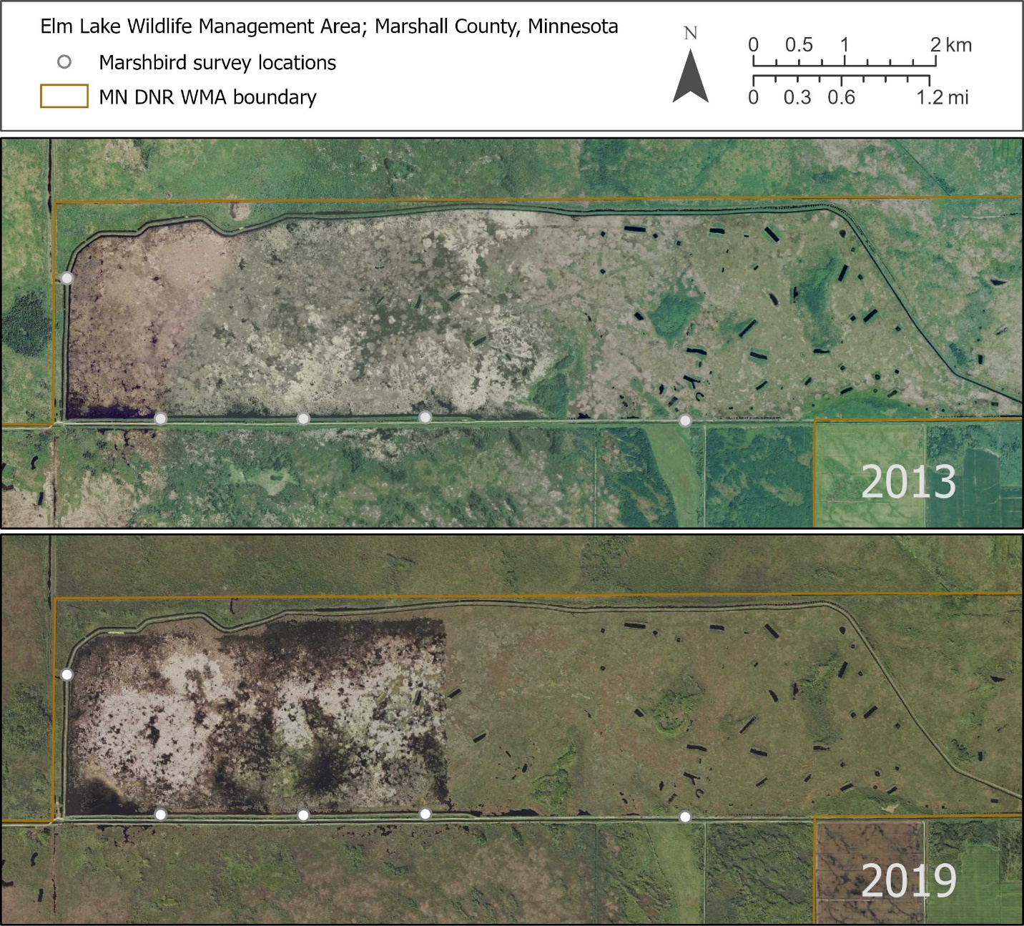

Figure S4. Spectral indices of treatment areas show decreased greenness and water reflectance after herbicide application occurred in August–September 2015 at marshbird study sites in northwestern Minnesota, USA. Greenness, measured as the Normalized difference vegetation index (NDVI), is shown in green and yellow bars that deviate from the mean of annual values 2010–2020. Water reflectance, measured as the Normalized difference water index (NDWI), is shown as blue and red points and lines that deviate from the mean of annual values over 2010-2020. We usedClimateEngine.org to obtain the indices' median values of pixels over the spray area polygons, and then calculated the mean values over the day range of northern growing season 1 June – 31 August for each year. Plots follow the order of spray areas at Beaches Lake, East Park, Eckvoll, Elm Lake, Pembina, Roseau River East, Roseau River West, Thief Lake, and Twin Lakes WMAs.

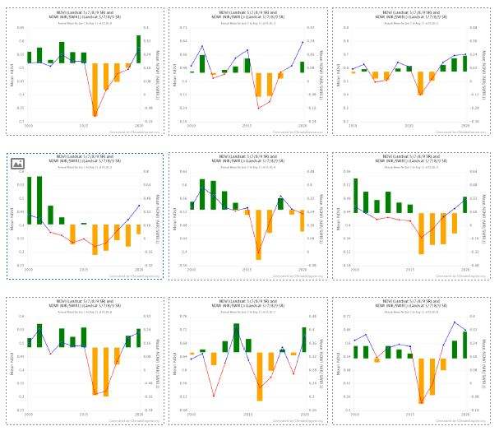

Figure S5. Land-cover-type composition surrounding marshbird survey locations in 2013 (2 years prior to the start of our study) in northwestern Minnesota, USA derived from 15-m resolution land cover data (Minnesota Land Cover Classification and Impervious Surface Area by Landsat and Lidar [2013 update - Version 2; <https://gisdata.mn.gov/dataset/base-landcover-minnesota>]). We summed pixels of each land-cover type within 400 m of survey locations, calculated percent cover for each land-cover type, and present the mean percent cover for treatment (herbicide and control study sites. Error bars represent 95% confidence intervals.

